Proposal for API Solution from WhiteBooks



Table of Contents
Table of Contents 2
Our DNA 3
WhiteBooks (BVM) Profile 3
WhiteBooks Authorized GST Suvidha Provider (GSP) 3
Products 4
APIs 4
Document Purpose 4
Scope of proposal 4
Our Methodology 4
Solution Overview 4
Pricing 5
Payment Terms 5
Support 6
Our Clients 7

Our DNA

WhiteBooks (BVM) Profile
- WhiteBooks is a product from BVM IT Consulting Services India Private Limited, which is a licensed GSP from GSTN.
- BVM is an award-winning startup that achieves its business goals by defining its Web- based (SME Development Company that helps enterprises, JS), Mobile-based business initiatives, and Cloud solutions, and helping them reap benefits from the latest technologies. Prior Extensive and Strong Experience in Indirect taxes software and India Taxation, We are extensive experience in Product Engineering, User Experience (UX/UI), ERP Development & Integration, E-Commerce Platform and Taxation.
- Founded in 2011and ISO27001 Certified Company
- 100+ProjectsDelivered and 150+TechnologyExperts
- Offshore product development and IT services Extended Team Model (ETM) For Dedicated Teams 50%y-o-y growth rate
- Headquartered In Hyderabad, India and London, UK

WhiteBooks Authorised GST Suvidha Provider (GSP)

GST Suvidha Providers are authorised Gateway providers for any software (ASP) to connect to GST Network. As an appointed GSP as well as having our own return filing solution (ASP), WhiteBooks is the first ASP – GSP from Hyderabad
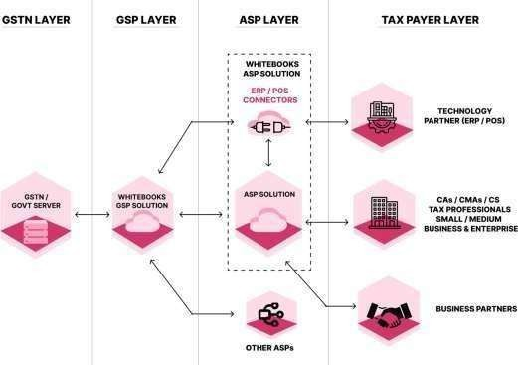

Document Purpose
This is the proposal document to consume WhiteBooks APIs as part of the WhiteBooks Web solution. The document lists the solution proposal, the scope of work and pricing.

Scope of proposal
The Scope of proposal on a High-Level includes:

- All New features will be automatically updated based on your subscription.
- Any additional support requirement will be included on case by case basis as an additional scope.

*GSTN /NIC Network will keep on updating the APIs (GST, E-Invoice, E-Way Bill) as part of the continuous improvement of their system and upon upgrade GSTN APIs WhiteBooks GSP Solution will also upgrade in line with GSTN APIs.

Our Methodology
We as a company follow best in industry practices which are adoptable and cost effective and high productive and timely delivery. We always understand the client system, process and methodologies and will recommend asper industry best practices if any opportunity to implement at client place.

Solution Overview

- List of available APIs are available on WhiteBooks Website.
  - E-Invoice - https://whitebooks.in/api/e-invoice-api-for-developers
  - E-Way Bill -https://whitebooks.in/api/e-way-bill-api-for-developers
  - GST API - https://whitebooks.in/api/gst-api-for-developers

Pricing

Subscription API Plans
Module | Pricing | Per API Call | No of API Calls
e-Invoice API | ₹15,000 | ₹0.10 | 1,50,000
e-WayBill API | ₹15,000 | ₹0.10 | 1,50,000
GST Public APIs | ₹10,000 | ₹0.10 | 1,00,000
GST public + GET | ₹15,000 | ₹0.10 | 1,50,000
GST Public + GET + POST | ₹25,000 | ₹0.09 | 2,77,778

- Above API calls are valid for 1 year if you consume above API calls with in 1 year you can Top up by using below plans

Top-up API Plans
Module | Pricing | Per API Call | No of API Calls
Production API Top-up | ₹ 15,000 | ₹ 0.10 | 1,50,000
Production API Top-up | ₹ 25,000 | ₹ 0.09 | 2,77,778
Production API Top-up | ₹ 50,000 | ₹ 0.08 | 6,25,000
Production API Top-up | ₹ 75,000 | ₹ 0.07 | 10,71,429
Production API Top-up | ₹ 1,00,000 | ₹ 0.05 | 20,00,000

Payment Terms
  - 18% GST is applicable to the above-mentioned price.
  - Unused API calls will not be roll over to the next year; however, renewal Subscription payment must be made each year to ensure uninterrupted API services.
  - Any additional enhancement will be charged and will consider as Change Request process

Support

Any additional support, whether on-premises or beyond the WhiteBooks solution scope, will be charged extra on an actual basis and must be pre-approved.For outstation, additional travel, stay and food charges will have to be paid at actuals.

Note: For Further Queries, please mail us at sales@WhiteBooks.in/info@WhiteBooks.in

or call us at +91 9032111788 | +91 9032111388

Your Point of Contact for this document (Primary contact)
Name | Nazeera
Title | Sales executive
Email | nazeera@whitebooks.in
Phone | +91 8106433737
Website | www.whitebooks.in

Your Point of Contact for this document (Secondary contact)
Name | Support
Title | Support Team
Email | support@whtiebooks.in
Phone | +91 9032111788 | +91 9032111388
Website | www.whitebooks.in

Our Clients:

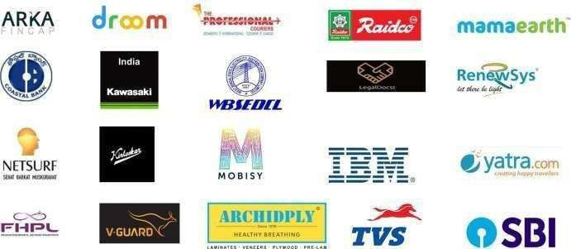
We have expanded across multiple domains and continue to support our satisfied customers.
